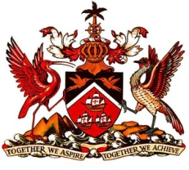

PERMANENT MISSION OF THE REPUBLIC OF TRINIDAD AND TOBAGO
TO THE OFFICE OF THE UNITED NATIONS, GENEVA

Statement at the Universal Periodic Review (UPR) of the Republic of Seychelles, Palais des Nations, Geneva, 25th January 2016

Thank you Mr. President.

Trinidad and Tobago wishes to express appreciation to the Delegation of Seychelles for the presentation of their second UPR report.

My delegation commends the efforts undertaken to improve the human rights framework and notes the strides made in legislative and policy development via the introduction of several pieces of legislation and review of policies relating to, inter alia, early childhood development, tertiary education, employment and health. Programmes for rehabilitation, reconciliation and reintegration into Seychellois society are certainly exemplary.

My delegation wishes to recommend that Seychelles consider the following:
1. Improve the accessibility of persons with disabilities, particularly children, to education and key services; and
2. Continue pursuing initiatives at improving the educational system with a view to further developing technical and vocational education and training.

Trinidad and Tobago extends best wishes to the Delegation of Seychelles for a successful review.

I thank you Mr. President.

